**St. Michael’s**

**Catholic School**

December 2023

Newsletter

**St. Michael’s School is a Peanut/Tree Nut Safe School**  December 2023

**Principal’s Message**

The Liturgical year begins with the Holy season of Advent on Sunday, December 3rd. Advent is a time where we prepare with HOPE for Jesus to enter our lives as the light of the world. Although Jesus is always present in our hearts, we use this special time to reflect on our many blessings and to pray for those in need. The school will use daily prayer, weekly Advent Liturgies, and good deeds for the community to live our faith as we await for the Birth of Our Saviour.

During this time, we prepare our homes, our hearts and ourselves for the birth, or coming, of Christ. It is my sincere hope that during this Advent season you take the time to reflect with your families and experience the true meaning of Christmas and what it means to prepare ourselves for Christ to be born in our hearts.

On behalf of St. Michael’s staff, I would like to take this opportunity to wish you all a blessed and very Merry Christmas and a safe and happy New Year.

Mrs. Kerri Lomax, Principal

**St. Michael’s Catholic School**

209 Alder Street W

Dunnville, ON N1A 1R3

(905) 774-6052

[www.stmichaeldunnville.ca](http://www.stmichaeldunnville.ca)

@stmcatholic

**ZONE 2**

Principal: Mrs. K. Lomax

Secretary: Mrs. M. Reidy

**Parish Information**

St. Michael the Archangel

204 Alder Street West, Dunnville

905-774-6972

Father Manuel

All are welcome to attend:

Saturday – 5 pm

Sunday – 8:30 am or 10:30 am

###### Absent/Late Students

If your child will be absent or late for schoolplease call the office before 9:00 am at

**905-774-6052**

###### 

###### 

###### 

**Board Website**

**www.bhncdsb.ca**

Please view the Board’s website for important information. The website includes calendars, Board policies and other useful information.

*.*

**School Bell Times**

**8:50 am: School Begins**

10:30-11:10 am

**1st Nutrition Break**

12:50-1:30 pm

**2nd Nutrition Break**

3:10 pm

**School Dismissal**

**Follow us on Twitter**

See what is happening at

St. Michael’s School

@stmcatholic

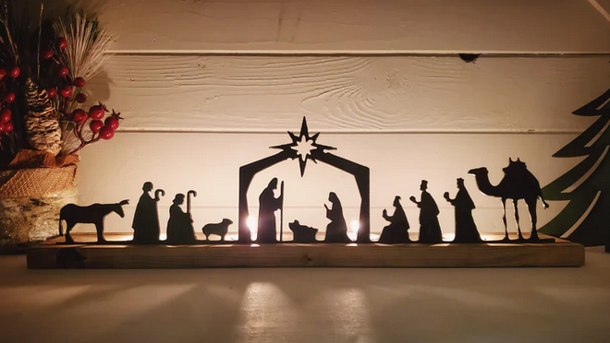

**Advent Celebrations**

Advent celebrations start on December 4th and will be led by our Student Parliament. Each Monday in December we will begin our day with an Advent liturgy.

**Pizza Days**

**This Month**

December 7

December 14

December 21

**Christmas Concert**

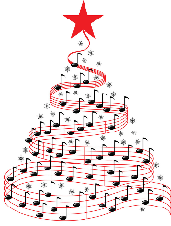We are excited to present our Christmas Concert this year. This special event will take place in the gymnasium on Thursday December 14th at 1:30 pm. Please consider a donation of a non-perishable item to be place under the tree that day.

**December Spirit Days**

The last week of school before the Christmas holidays we will get in the festive mood with theme days.

**Monday, December 18 – Red/Green Day**

**Tuesday December 19 – Christmas Headwear Day**

MARK YOUR CALENDARS

**PA Days**

**January 22**

**April 19**

**June 3 & 28**

**Christmas Break**

**December 25 – January 5**

**School Council Meeting**

**January 29**

**Term 1 Reports**

**February 5**

**Family Day**

**February 19 (no school)**

**March Break**

**March 11 - 15**

**Wednesday December 20 – Ugly Sweater Day**

**Thursday December 21 – Christmas Accessory Day**

**Friday December 22 – Pajama/Comfy Day**

**Movie Field Trip: MIGRATION**

On Friday Dec 22nd, all students will be travelling to Seaway Cinema in Welland to see the movie MIGRATION. Permission forms have been sent home with the students. Please make sure to sign and return them to the school**. Canteen items and tickets must be purchased through School Cash Online between December 1st – 15th.**  Please set a reminder so your child doesn’t miss out!!

**Jr. Basketball Tournament**

Our Jr. Basketball Team will be heading to Holy Trinity Catholic High School on Friday December 15th to participate in the board wide tournament. Please make sure that your student has proper gym attire/ running shoes are mandatory. Permission forms have been sent through School Cash Online for those students who have made the team.

**Dunnville Christmas Parade**

On Saturday December 2, 2023, St. Michael’s School will be participating in the Dunnville Christmas Parade. All students and families are invited to participate. Please see newsletter that was sent home with the students for more information.

**Scholastic Book Fair**

A huge THANK YOU to all those who were able to visit our Scholastic Book Fair either at school or online. It was a huge success and our library earned $2100.00 in books!! Congratulations to our door prize winners, Jacob (Gr. 1) Kailyn (Gr. 6). They both won $25.00 in books for themselves and $25.00 each for their classrooms. A special thanks goes to Mrs. Gohn our librarian who organized the event and enabled the book fair to take place, and to our Grade 8 volunteers for all their help!!! We can’t wait to see our students’ faces when they come into the library and see all the shiny new books on our shelves**.**

***Christmas Season Prayer***

***May the love that breathes life into all of humanity, born in us this Christmas be Season.***

***May the love that brings forth all of creation, be born in us this Christmas season.***

***May the love that overcomes hatred and brings healing, be born in us this Christmas season.***

***May the love that forgives and renews, be born in us this Christmas season.***

***May the love that brings the fruits of justice, be born in us this Christmas season.***

***May the love that brings the blessing of peace, be born in us this Christmas season.***

***May that peace now be the gift we share with all our brothers and sisters.***

**Candy Cane Fundraiser**

Beginning on Friday December 1st, our Student Parliament Team will be selling candy canes to help to raise funds for their Grade 8 year end trip to Camp Celtic. Candy canes are $1.00 each and will be sold every MONDAY, WEDNESDAY AND FRIDAY, with the last day of sales being Wedneday December 20th.

**Remembrance Day Poster and Literacy Contest**

Congratulations to Joseph T. and Brea M. for placing 2nd in the Dunnville Legion Remembrance Day Contest. Joseph placed second in the JR Black and White poster category and Brea placed second in the JR Colour poster category. Congratulations to you both!!

**Picture Retake Day**

Picture retakes will be held on **Monday December 11, 2023**. Please let your child’s teacher know if you would like retakes done.

**Parent Council Information**

****Christmas Shopping Extravaganza**

The Parent Council are very excited to announce that the Christmas Shopping Extravaganza will be running this year. The event will take place on December 21st and students will have the opportunity to “shop” for gifts for their family.



**Gingerbread Raffle**

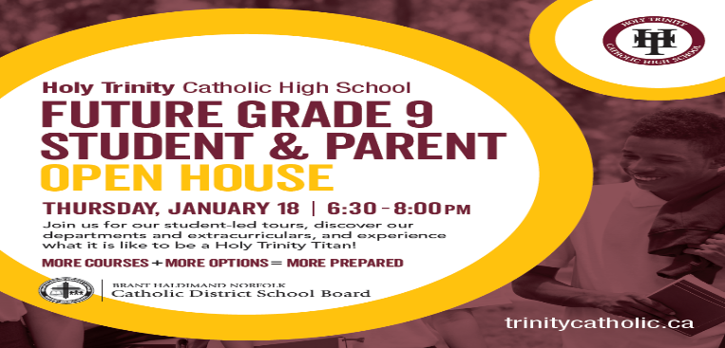A huge gingerbread house full of goodies has been donated to the school and will be raffled off at the Christmas Concert. The house will be on disply at the school December 11 and students will be given the pportunity to purchase tickets for $1. The raffle will take place on December 14th.

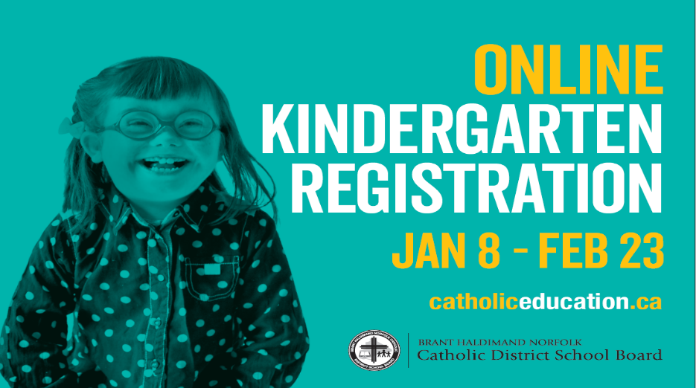All proceeds made from these events will go towards our Healthy Snack Program.



